

**Green University of Bangladesh**

**Department of Computer Science and Engineering(CSE)**

**Semester: (Summer, Year:2021), B.Sc. in CSE (Day)**

Lab Report-03

Course Title:  Web programming Lab

Course Code: CSE-302               Section:193DE

**Student Details**

|  |  |  |
| --- | --- | --- |
| Name | | ID |
| 1 | Jakirul Islam | 193002101 |

Submitted Date :08.12.2021

Course Teacher’s Name : Feroza Naznin

|  |
| --- |
| Status  Marks: …………………………………                              Signature:.....................  Comments:..............................................                              Date:.............................. |

**Tittle:** Design and develop a basic Form where the user input will be showed by a table using basic java script DOM

**Objectives :**

1. to gain basic understanding of HTML
2. to know the designing a basic form using javascript

**Procedure :**

1. First of all I installed vs code.

2. Secondly, I created HTML and CSS file.

3. Finally, I have input the javascript code into HTML body.

**code :**

<!DOCTYPE html>

<html lang="en">

<head>

    <meta charset="UTF-8">

    <meta http-equiv="X-UA-Compatible" content="IE=edge">

    <meta name="viewport" content="width=device-width, initial-scale=1.0">

    <title>Form</title>

    <!-- css style start -->

    <style>

        .continer{

            width: 100%;

            height: 750px;

            background-color: gray;

        }

       .form-field{

           display: flex;

           justify-content:left;

       }

       .input-field{

              width: 500px;

              height: 70px;

              margin: 10px;

       }

       .input-field input{

           width: 450px;

           height: 40px;

       }

       .btn-field{

              width: 180px;

              height: 50px;

              margin: 10px;

              background-color: black;

              border-radius: 5px;

              color: white;

       }

       .btn-field:hover{

           background-color: #f7a5a5;

           transition: .5s;

       }

       .div-table{

              display: flex;

              justify-content:left;

              margin: 10px;

              padding: 0px;

       }

       .table{

                width: 450px;

                height: 100px;

                margin: 10px;

                border: 1px solid black;

                border-collapse: collapse;

                text-align: center;

       }

       .table td{

                border: 1px solid black;

                padding: 10px;

       }

    </style>

    <!-- css style end -->

</head>

<body>

    <div class="continer">

      <div class="form-field">

        <form id="form-data">

            <div class="input-field">

                <label for="name">Student Name:</label>

                <br>

               <input id="name" type="text" name="name" placeholder="name">

            </div>

            <div class="input-field">

                <label for="id">Student ID:</label>

                <input id="id" type="text" name="id" placeholder="Student id">

            </div>

            <div class="input-field">

                <label for="dept">Department Name:</label>

               <input id="dept" type="text" name="dept" placeholder="Department name">

            </div>

            <div class="input-field">

                <label for="uni">University Name:</label>

               <input id="uni" type="text" name="uni" placeholder="university name">

            </div>

            <input type="submit" value="submit" class="btn-field">

        </form>

      </div>

        <br>

       <div class="div-table">

        <table class="table">

            <thead>

                <tr>

                    <th>Student Name</th>

                    <th>Student ID</th>

                    <th>Department Name</th>

                    <th>University Name</th>

                </tr>

            </thead>

            <tbody id="table-data" class="table">

                <tr>

                    <td id="td1"></td>

                    <td id="td2"></td>

                    <td id="td3"></td>

                    <td id="td4"></td>

                </tr>

            </tbody>

        </table>

       </div>

    </div>

 <!-- js start  -->

    <script>

        var form = document.getElementById('form-data');

        form.addEventListener('submit', function(e){

            e.preventDefault();

            var name = document.getElementById('name').value;

            console.log(name);

            var id = document.getElementById('id').value;

            var dept = document.getElementById('dept').value;

            var uni = document.getElementById('uni').value;

            var td1 = document.getElementById('td1').innerHTML = name;

            var td1 = document.getElementById('td2');

            var td1 = document.getElementById('td3');

            var td1 = document.getElementById('td4');

            td2.innerHTML = id;

            td3.innerHTML = dept;

            td4.innerHTML = uni;

        });

    </script>

    <!-- js end  -->

</body>

</html>

**Output:**

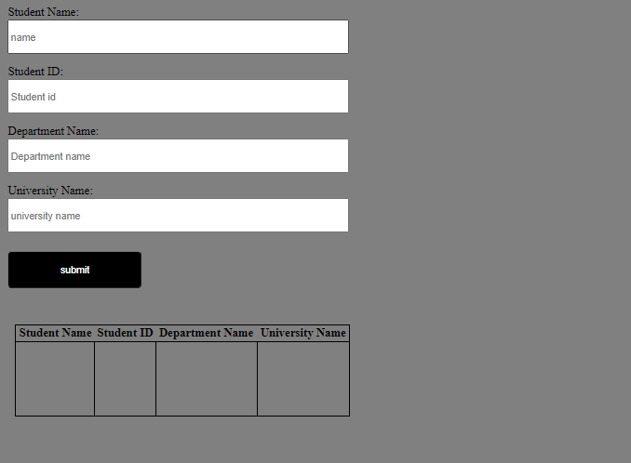

**Discussion :**

1. I have faced difficulty creating HTML form.

2. I have taken a function addEventListener.

3. In the function I haved called the HTML's id by getElementById carefully.

4. I have organised the form using css.

5. I have used displayflex for the alignment of the form.